**Object Detection Project:**

**Find the iPhone**

Hamidreza Farhidzadeh

**Target of Project**

* Find the center point of the iPhone in an image

**Requirements**

* Python 3.6
* Deep Leaning Package: Keras + Tensorflow-gpu
* Numpy and sklearn python

**Items**

* data.py
* find_phone.py
* train_phone_finder
* find_phone, find_phone_test_images and best_model folders

1. data.py

The data.py script prepare the data for training process. In this code, the center for each image is taken and by using (x, y), it makes the while square with 40*40 dimensions in black mask in size of original image.

Finally, both images will be resized to 256 * 256 and passed to find_python.py



1. train_phone_finder

if you want to work on CPU

os.environ["CUDA_VISIBLE_DEVICES"] = "-1"

In this code, [Unet CNN](https://arxiv.org/pdf/1505.04597.pdf) model is implemented. The idea is to do image segmentation. After training the model and it’s weights will be saved in unet.hdf5 file.

1. find_phone.py

In this code, the model will be loaded and tested on input image. Also, the mask result is saved in result.jpg.

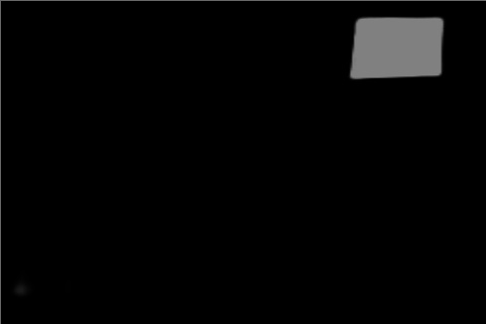

Finally to the center of output mask will be reported.

Best model is saved in best_model folder.